* **A description of the data to be used**
  + **You can choose any *publicly available dataset*(s). Good resources for finding data include Kaggle, Google dataset search, and the UCI Machine Learning Repository.**
  + **Briefly describe the dataset and variables you plan to visualize.**
  + **If you need to preprocess the data (including application of ML or NLP models), describe how this will be done and what tools you will use.**
* **Encoding: What are the visualizations and interactions that will be supported.**
  + **Remember that 1 visualization needs to be innovative, either a novel visualization design or an extension of an existing technique. Describe its characteristics, and why it is special.**
  + **You should include a set of sketches showing your proposed designs and interactions (~3-5 sketches). Sketches can be photographs of pen and paper, but they should look nice.**

A description of the data to be used:

Briefly describe the dataset and variables you plan to visualize:

This data sets shows the raw numbers of deaths by week in the United States in 2020 versus the same weeks of the five previous years 2015 to 2019. We plan to show a comparison between this time period and the effects on the mortality rate Covid-19 has had. Ancillary data from this set is also displayed. Specifically, we will show the effect of the mortality rate by age group and how this ration has changed from the previous years to the current year, which will reflect how Covid-19 has changed this ratio.

The dataset itself will need little processing, but in order to make the loading of the data faster and easier to work with the data will be striped down to only the information that will be used for the page. This means striping out information from other countries as to not have to “work around” this information when loading data and to speed up the data so the user will hopefully see more instantaneous reactions to their choices.

What are he visualizations and interaction that will be supported:

We will be supplying a dashboard that visualizes this data. The dash board will include three different ways to view this data. First the center visual element will be a line graph that shows the overall deaths by week over the time period of 9 – 10 months of data depending on what is available by time of completion of project. The data changes every week as information is solidified. This chart will have a toggle that will allow you to remove the deaths from Covid-19 to see a potential mortality count without the virus. *Please note are group is aware that simply taking this information out does not constitute a factual representation of what the mortality count would be without Covid-19 as the disease potentially causes more deaths due to its ancillary effects, but we as we assume other users find this information interesting. When s specific datapoint on the chart is click it will have the effect of changing the information shown in the two other visual elements on the page.

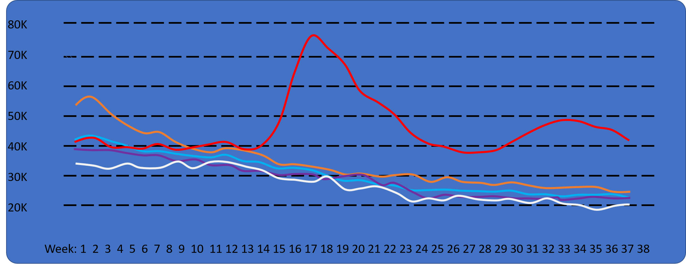

The next element is a bar chart that will show differences in mortality count by week, a more granular view the data. By default, this will show the most dramatic difference in the data which in our current set is week 15.

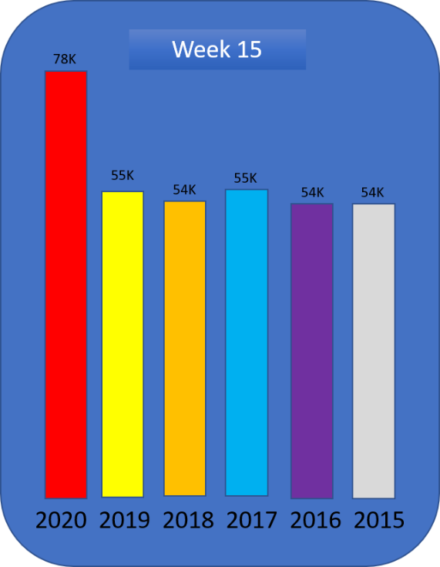

The third and last element of our chart will be a pie/ring chart, a data visualization that hasn’t been discussed much in this class on one our group is excited to incorporate into our dashboard. This Viz. will give users a different way of looking at the dataset it will display a breakdown of the mortality count for that week by age group. This will allow users to see in Covid-19 has changed this ratio in comparison to other years.

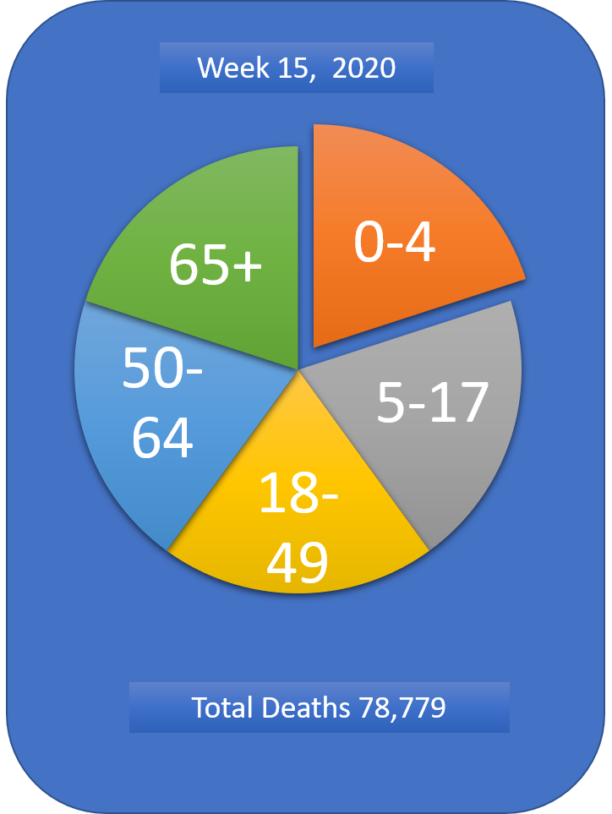

All three together:

